**Monday, 19 September, Tallahassee to Bucharest (via Atlanta and Amsterdam)**

Written 19 September 2022, 9:30 am, Amsterdam time

Shoulder against an open door. We were worried about David's 1.5-hour connection in Amsterdam, especially in light of all the horror stories coming out about long delays at Schiphol. Delta Airlines wouldn't be operating that third leg, from Amsterdam to Bucharest, and we've had a long history of their refusing to issue boarding passes for flights they don't operate, so we figured we'd have to get David's boarding pass from one the the kiosks in the Amsterdam airport, then find his gate. I still wasn't worried, since the last time we flew somewhere through that airport, we did that and still made the connection in half an hour.

But to our astonishment, the Delta check-in kiosk in Tallahassee cheerfully printed all three of our boarding passes on the first try. And in Amsterdam, we made it from our seats on the plane to David's departure gate in 20 minutes flat! And a good third of that was hiking to the nearest TV monitor to get his gate number before retracing our steps toward the gate itself. Piece of cake!

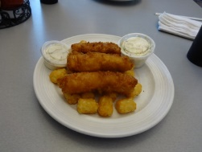But back to the beginning. At the airport, we ran into Shannon Sauls, executive director of Westminster Oaks headed out of town with a group of friends, also to visit several destinations in Europe, but none that will cross our path. I enjoyed this tasty plate of fish and chips (actual cod!) while David had a patty melt.

The flight to Atlanta was uneventful and on time, but our attempt to avail ourselves of the Delta VIP lounge on our concourse came to naught. We arrived to find a queue of about 30 people waiting to get in, in front of a large sign declaring that the lounge was already at capacity and that others could enter only when somebody left. The sign did not have a make-shift look—it was professionally printed in Delta's colors on a permanent panel that they could slide out whenever it was needed.

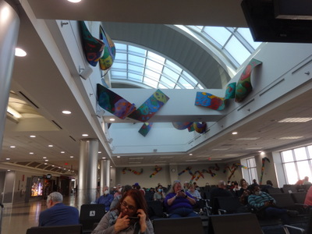So we repaired to our gate to wait as usual, where this art was on display on the ceilings.

During our wait, we were quietly amused by a group of half a dozen middle-aged ladies travelling together who strongly reminded us of that TV ad featuring the guy to tries to keep young home owners from turning into their parents. It shows a woman reminding others in her group not to buy snacks for the flight, since she's brought plenty from home. The ladies sitting near us were shuffling snacks from bag to bag (to make sure nobody had more than two carry-ons), exchanging in the process about two pounds each of pistachios, yogurt-covered raisins, cashews, KitKat bars, Skittles, and ziplock bags of homemade munchies.