3 October 2022, Passau, Germany

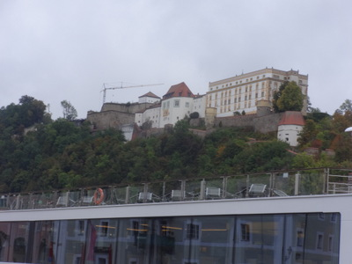We arrived in Passau at breakfast time and set off on our walking tour of the city (leisurely option) right from the ship—no bus involved. This photo shows the Prince Bishop Elector's palace, which overlooks the town from the opposite bank of the Danube.

He ruled the town for a good while, and the town didn't like it. First, the poor people rebelled because the bishop was clearly living the high life off their taxes. Then the rich merchants rebelled because they wanted independence from him. But the bishop always won—he literally had the high ground.

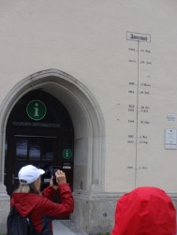This is the door to the tourist information office in the town hall square, with the high-water marks from various historical floods. The place has always been prone to floods. It's at the confluence of the Danube, the Inn (actually larger than the Danube at this point), and the Ilz. Floods are less of a problem now than the river is dammed and locked, but floods still happen. The all-time worst (the mark just below the sign at the top, which just says "water marks" was in 1501 AD. The second worst (the next mark below that) was in 2013! Yikes! You can see the size of the door and the heads of the people standing around . . .

When we walked the short distance from the Danube to the Inn, the guide remarked that the Inn was very high because of the recent rains upstream—it was beginning to wash over the edge of the river-side walk. Although disappointed, we were therefore at least a little forewarned when the Viking crew announced that our afternoon excursion had been cancelled. We were supposed to take a little barge side cruise up the Inn to tour the baroque town of Schärding, but the Inn was raging, and the cruise was deemed unsafe.

Then, at the predinner briefing, the tour director outlined tomorrows already rather complicated plans before revealing that the chances were about 50-50 that we wouldn't be able to get the ship under one of the bridges between Passau and our next destination, Regensberg. We're due to get there ca. 2 am, and we'll find out in the morning whether we were able to get under it, whether we're downstream of it waiting for daylight before trying, or whether it's hopeless and we're stuck for a day until they can open the locks downstream to try to let some of the water drain away. At that point, there's a plan B involving very complicated logistics, which we be explained to us if necessary. All this time we've been worried about low water, and now high water is threatening to derail us (to mix a metaphor)!

But just this minute, I see on the bow camera that a cruise ship has passed us coming downstream. I hope it's a good sign that they were able to get through.