**Wednesday, 12 April, The storm surge barriers at Walcheren and the great flood of 1953**

Written 12 April 2023

Last day on the ship. We leave for the airport at 6 am tomorrow, and we should be in Tallahassee by 6:30 or 7 pm Thursday.

Today,we got a second shot at Kukenhof Gardens, and what a difference two weeks makes!

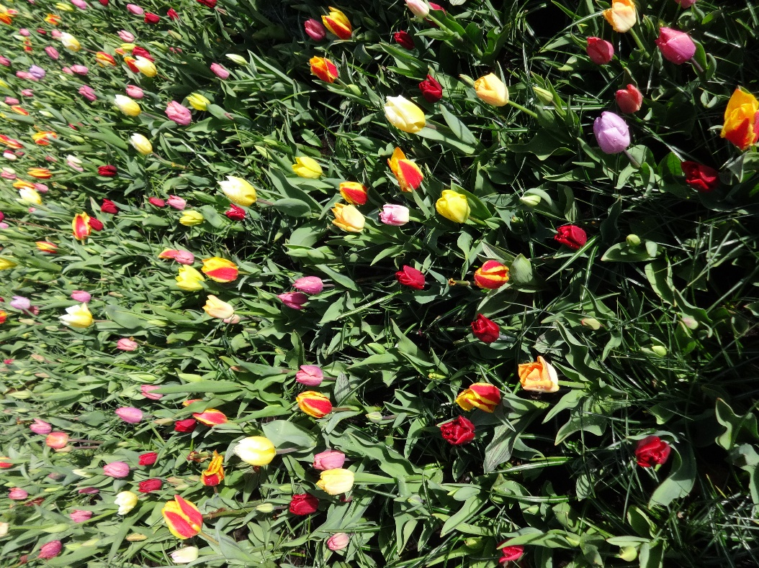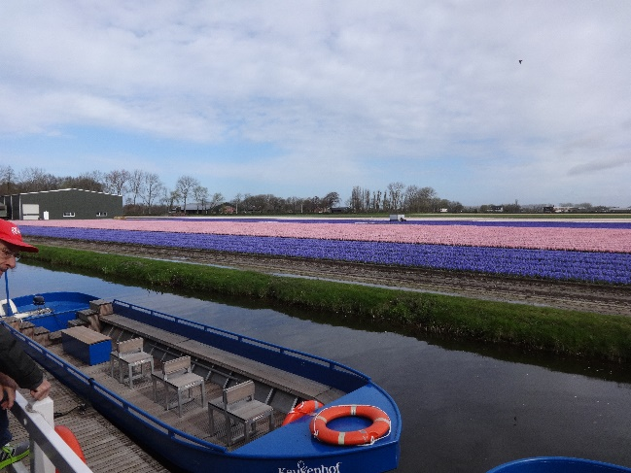

Here's the flower mound inside the entrance that I showed the last time we were there. All the crocuses and most of the daffodils have disappeared, replaced by first wave of tulips. At the right are commercial fields of hyacinths, as we looked outward from the boundary of Keukenhof.

Tulips as far as the eye could see, plus scyllas, hyacinths, grape hyacinths, begonias, and many others!

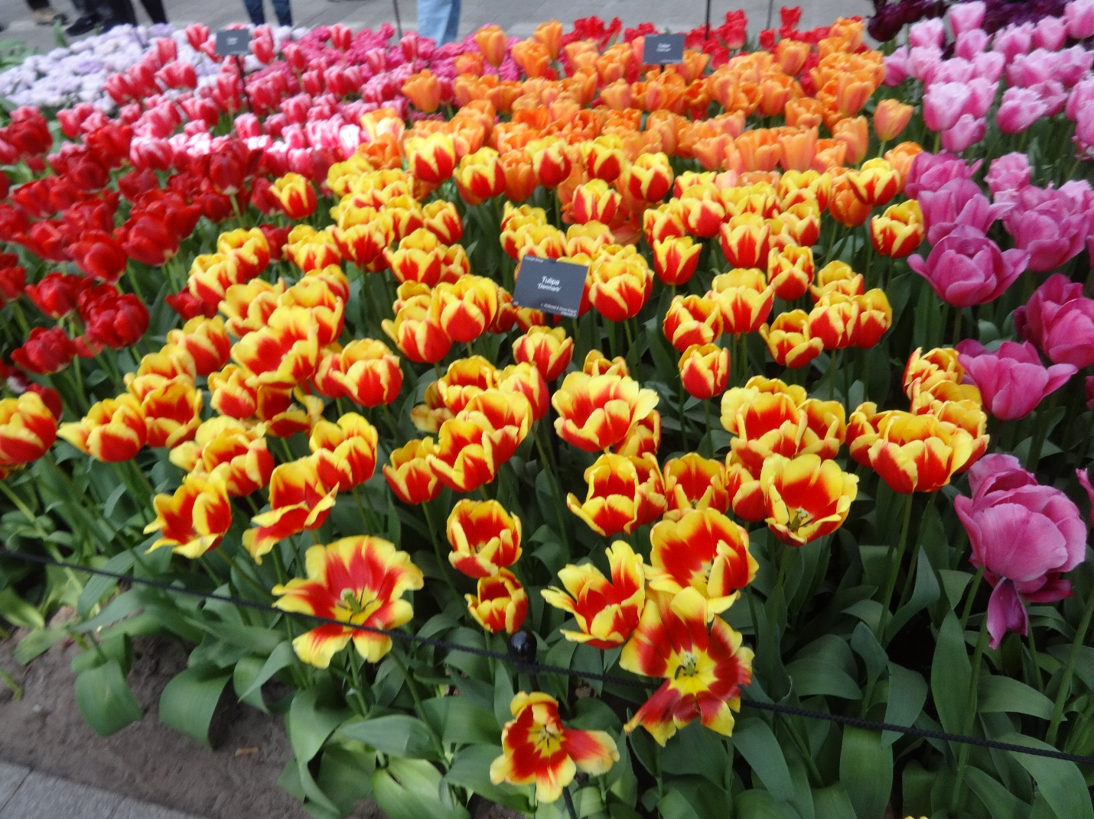

From Keukenhof, Rachel, David, and I, plus two friends of Mike Castellini who now live in Florida. Went on to Haarlem to tour the historic district and to visit the Franz Hals museum.

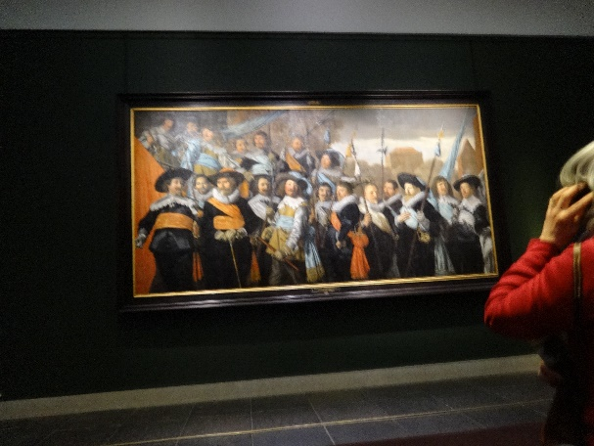After a pleasant lunch in a restaurants on the river (spicy oriental pumpkin lentil soup, beef steak kabobs, and chocolate mousse), the guide took us on the scenic route to the museum.

The church, town hall, and butchers' guild are magnificent, but a deafening fun fair was set up in the space between them, so the guide led us a block away and around a corner before doing his spiel.

Here's the sort of thing Hals painted—group portraits of guilds and members of the city watch (sorry it's so blurry). His were noticeably better than many similar group portraits of the period. We saw many more, but I'm tired, and I've got to pack. See you soon!